Introduction and Data Overview

Subtask:
Provide an introduction to the analysis, covering the dataset's purpose, initial inspection (head, info, describe), handling of missing values, and the text cleaning process.

Introduction to Student Satisfaction Survey Data Analysis
This analysis aims to perform a comprehensive examination of student satisfaction survey data. The primary goal is to extract meaningful insights from student feedback, identify key areas of strength and weakness within academic programs, and provide actionable recommendations for improvement. By analyzing various metrics, including percentage ratings for different questions and sentiment expressed in textual feedback, we can gain a holistic understanding of student perceptions.

Data Overview and Initial Inspection
The dataset, loaded into a pandas DataFrame named df, was initially inspected using df.head(), df.info(), and df.describe().
- df.head(): Revealed the first few rows of the dataset, showcasing columns such as SN, Total Feedback Given, Questions, Average/ Percentage, Course Name, and Basic Course. This gave us an initial understanding of the data structure.
- df.info(): Indicated that the dataset contains 580 entries and 12 columns. It showed that all columns are non-null, with SN, Total Feedback Given, Total Configured, and Weightage columns being int64, and Questions, Average/ Percentage, Course Name, and Basic Course being object (strings). This confirmed the absence of immediate missing values and highlighted the need to potentially convert Average/ Percentage for numerical analysis.
- df.describe(): Provided descriptive statistics for the numerical columns, offering insights into the distribution and central tendency of metrics like Total Feedback Given and the various Weightage columns. This helped in understanding the scale and variability of the feedback counts.

Handling Missing Values and Duplicates
Before proceeding with the analysis, df.isnull().sum() was used to check for missing values across all columns. The output confirmed that there were no null entries in any of the columns. Additionally, df.drop_duplicates(inplace=True) was applied to ensure that all entries in the DataFrame were unique, preventing any potential biases from duplicate records. Both operations were completed without removing any rows, indicating a clean dataset in terms of missing and duplicate entries.

Text Cleaning Process
To prepare the textual Questions for sentiment analysis, a cleaning function clean_text was applied to create a new column called Clean_Feedback.
- Lowercasing: All text was converted to lowercase to ensure uniformity and prevent the same word with different capitalizations from being treated as distinct entities.
- Removing URLs: Any URLs present in the text were removed as they typically do not contribute to sentiment.
- Removing Non-Alphabetic Characters: Punctuation, numbers, and other special characters were removed, retaining only alphabetic characters and spaces. This step standardizes the text, making it suitable for subsequent natural language processing tasks like sentiment analysis, by focusing solely on the words themselves.

Average Percentage Rating by Question Analysis

Subtask:
Summarize the average percentage ratings for questions. Generate a bar plot showing the top 5 and bottom 5 questions based on their average percentage ratings.
Reasoning: First, I'll identify the top 5 and bottom 5 questions from the question_ratings_percentage Series and store them in separate variables.
top_5_questions = question_ratings_percentage.head(5)
bottom_5_questions = question_ratings_percentage.tail(5)

print("Top 5 Questions (by Average Percentage Rating):")
print(top_5_questions)
print("\nBottom 5 Questions (by Average Percentage Rating):")
print(bottom_5_questions)

Output:-
Top 5 Questions (by Average Percentage Rating):
Questions :-
*Fairness of the internal evaluation process by the teachers. 84.296897
*How well were the teachers able to communicate? 83.946552
*How well did the teachers prepare for the classes? 81.793793
*The teachers illustrate the concepts through examples and applications. 81.331034
*Teachers inform you about your expected competencies, course outcomes and program\noutcomes. 79.603448
Name: Percentage_Rating, dtype: float64
Bottom 5 Questions (by Average Percentage Rating):
Questions
*Teachers are able to identify your weaknesses and help you to overcome them. 74.079310
*The institute takes an active interest in promoting internships, student exchange, field visit opportunities for students. 72.374483 T
*he teachers identify your strengths and encourage you to provide the proper level of challenges. 72.304483
*What percentage of teachers use ICT tools such as LCD projectors, Multimedia, etc. while teaching? 71.682414
*The teaching and mentoring process in your institution facilitates you in cognitive, social and\nemotional growth. 71.578966
Name: Percentage_Rating, dtype: float64

Reasoning: I need to visualize both the top 5 and bottom 5 questions using a bar plot. I will combine these two series, assign them appropriate labels for distinction, and then plot them on a single bar chart using subplots to clearly separate the top and bottom questions.

plt.figure(figsize=(12, 10))

plt.subplot(2, 1, 1) # 2 rows, 1 column, first plot
sns.barplot(x=top_5_questions.values, y=top_5_questions.index, palette='viridis')
plt.title('Top 5 Questions by Average Percentage Rating')
plt.xlabel('Average Percentage Rating')
plt.ylabel('Question')
plt.xlim(0, 100) # Ensure consistent x-axis for comparison

plt.subplot(2, 1, 2) # 2 rows, 1 column, second plot
sns.barplot(x=bottom_5_questions.values, y=bottom_5_questions.index, palette='plasma')
plt.title('Bottom 5 Questions by Average Percentage Rating')
plt.xlabel('Average Percentage Rating')
plt.ylabel('Question')
plt.xlim(0, 100) # Ensure consistent x-axis for comparison

plt.tight_layout() # Adjust layout to prevent labels from overlapping
plt.show()

Output:-
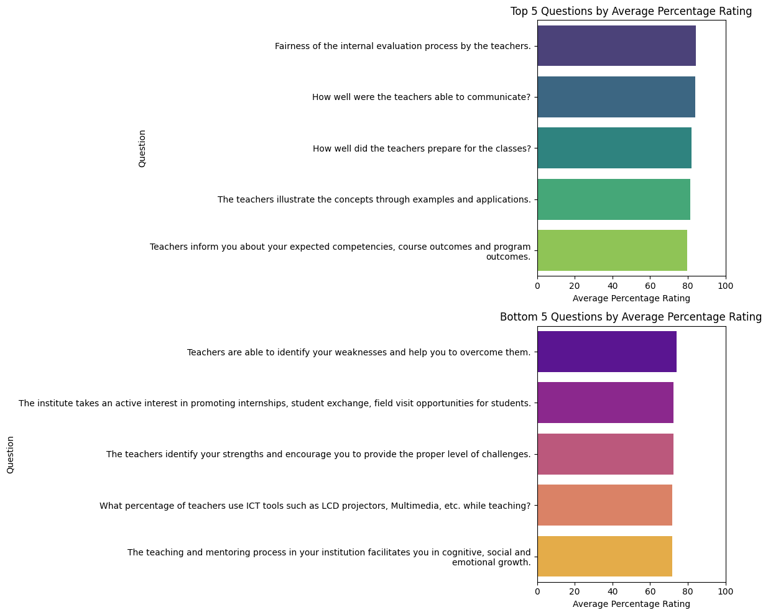

Average Percentage Rating by Course Name Analysis

Subtask:
Summarize the average percentage ratings by course name. Re-generate and interpret the bar plot showing the 'Average Percentage Rating by Course Name'.
Reasoning: To summarize the course_ratings_percentage Series and interpret the bar plot, I need to first display the series to see all the courses and their average ratings.
print(course_ratings_percentage)
Output:-
Course Name
FYBA 91.0000
MSC ANALYTICAL CHEMISTRY SEM I 90.5000
TYBSC 90.4440
MSC INFORMATION TECHNOLOGY - 1 90.0000
SYBMS 87.1430
FY BCOM (BANKING & INSURANCE) 87.0000
M.SC PART - 2 COMPUTER SCIENCE 84.5715
MSC INFORMATION TECHNOLOGY - 3 84.1660
S.Y.B.A.F 82.6510
TYBA 82.4115
FYBMS 81.3845
FY BCOM (ACCOUNTING & FINANCE) 80.3920
MSC ORGANIC CHEMISTRY - 3 79.4705
TYBMS 77.0000
FYBSC 76.2500
TYBCOM 74.7435
MA PSYCHOLOGY - 1 74.6000
SYBCOM 74.0260
MSC MICROBIOLOGY - 3 73.8575
MSC ANALYTICAL CHEMISTRY SEM III 70.8575
MA PSYCHOLOGY - 3 69.4290
M.SC PART - 1 COMPUTER SCIENCE 69.2500
MSC PHYSICS - 3 68.5000
FY B.VOC FOOD TECHNOLOGY 68.0000
MSC MICROBIOLOGY - 1 67.6665
MSC DATA SCIENCE - 3 67.3330
SY COMPUTER SCIENCE 67.0735
SYBSC 64.4285
MSC DATA SCIENCE - 1 54.6660
Name: Percentage_Rating, dtype: float64

Interpretation of Average Percentage Rating by Course Name
The bar plot titled 'Average Percentage Rating by Course Name' visually represents the student satisfaction levels across various courses. The course_ratings_percentage series provides the exact average rating for each course, sorted in descending order.
Observations:
- Top-Performing Courses: Courses such as 'FYBA' (91.00%), 'MSC ANALYTICAL CHEMISTRY SEM I' (90.50%), and 'TYBSC' (90.44%) show the highest average percentage ratings, indicating strong student satisfaction in these programs. 'MSC INFORMATION TECHNOLOGY - 1' (90.00%) also performs very well.
- Mid-Range Performance: A significant number of courses fall into a mid-range satisfaction level, generally between 70% and 85%. This includes programs like 'S.Y.B.A.F' (82.65%), 'TYBA' (82.41%), and 'FYBMS' (81.38%), 'FY BCOM (ACCOUNTING & FINANCE)' (80.39%).
- Lower-Rated Courses: Courses such as 'MSC DATA SCIENCE - 1' (54.67%), 'SYBSC' (64.43%), 'SY COMPUTER SCIENCE' (67.07%), 'MSC DATA SCIENCE - 3' (67.33%), and 'MSC MICROBIOLOGY - 1' (67.67%) have notably lower average percentage ratings compared to others. These areas might require closer examination to understand the underlying reasons for lower satisfaction.
Key Takeaways:
- There is a considerable variation in student satisfaction across different course names, ranging from excellent ratings above 90% to relatively lower ratings below 60%.
- Postgraduate science courses (e.g., MSC Analytical Chemistry) and some undergraduate arts and science programs (e.g., FYBA, TYBSC) generally show high satisfaction.
- Some specific computer science and data science courses, particularly 'MSC DATA SCIENCE - 1' and 'SY COMPUTER SCIENCE', appear to be areas needing attention, as they consistently receive lower average ratings.
- The visual representation effectively highlights the courses that are excelling and those that might need targeted improvements.

Sentiment Analysis (TextBlob)

Subtask:
Explain the TextBlob sentiment analysis, including how sentiment scores and labels were derived. Re-generate and interpret the pie chart showing the 'Sentiment Distribution (TextBlob)'.

TextBlob Sentiment Analysis Explanation
TextBlob is a Python library for processing textual data. It provides a simple API for common natural language processing (NLP) tasks, including sentiment analysis. For sentiment analysis, TextBlob returns two properties: polarity and subjectivity.
Sentiment Scores (Polarity):
The get_sentiment function, applied to the Clean_Feedback column, calculates the polarity score for each feedback entry. This score is a float within the range [-1.0, 1.0], where:
- 1.0 represents a very positive sentiment.
- 0.0 represents a neutral sentiment.
- -1.0 represents a very negative sentiment.
The calculation TextBlob(text).sentiment.polarity uses TextBlob's default sentiment analysis model, which is based on pattern-recognizer and NLTK corpora, to determine the emotional tone of the text.
- If Sentiment_Score > 0, the sentiment is labeled "Positive".
- If Sentiment_Score < 0, the sentiment is labeled "Negative".
- If Sentiment_Score == 0, the sentiment is labeled "Neutral".
plt.figure()
df["Sentiment"].value_counts().plot(kind="pie", autopct="%1.1f%%")
plt.title("Sentiment Distribution")
plt.ylabel("")
plt.show()

Output:-
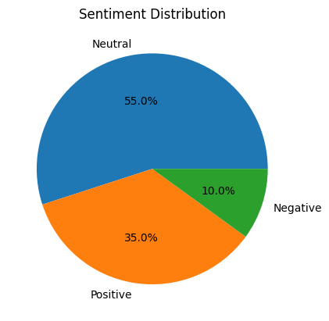

Sentiment Analysis (VADER) and Comparison

Subtask:
Explain the VADER sentiment analysis and how it was applied. Re-generate and interpret the heatmap comparing 'Sentiment' (TextBlob) and 'VADER_Sentiment'.

VADER Sentiment Analysis Explanation
VADER (Valence Aware Dictionary and sEntiment Reasoner) is a lexicon and rule-based sentiment analysis tool that is specifically attuned to sentiments expressed in social media, but also works well on general texts. It does not require any training data and is good at handling common informal language.
How it works:
VADER calculates a sentiment score for a given text by looking at a lexicon of words that are labeled as positive or negative. It also takes into account common linguistic conventions that express sentiment intensity, such as punctuation (e.g., exclamation marks), capitalization (e.g., ALL CAPS), degree modifiers (e.g., "very good"), and conjunctions (e.g., "but").
The analyzer.polarity_scores(text) method returns a dictionary of scores for negative, neutral, positive, and a 'compound' score.
Compound Score:
The 'compound' score is the most useful metric for sentiment classification. It is a normalized, weighted composite score ranging from -1 (most extreme negative) to +1 (most extreme positive). It is calculated by summing the valence scores of each word in the lexicon, adjusted according to the rules, and then normalized to be between -1 and +1.

Application and Classification:
In this analysis, the vader_sentiment function was applied to the Clean_Feedback column to create the VADER_Sentiment column. The classification logic for VADER sentiment is based on the compound score:
- If the compound score is >= 0.05, the sentiment is classified as "Positive".
- If the compound score is <= -0.05, the sentiment is classified as "Negative".
- Otherwise (if the compound score is between -0.05 and 0.05), the sentiment is classified as "Neutral".
Reasoning: Now that the VADER sentiment analysis has been explained, I will re-generate the heatmap comparing TextBlob's 'Sentiment' and VADER's 'VADER_Sentiment' categories.
from matplotlib import pyplot as plt
import seaborn as sns
import pandas as pd
plt.subplots(figsize=(8, 8))
# Create a cross-tabulation of TextBlob Sentiment and VADER Sentiment
# This counts how many times each combination of sentiment labels occurs
df_comparison = pd.crosstab(df['VADER_Sentiment'], df['Sentiment'])
sns.heatmap(df_comparison, cmap='viridis', annot=True, fmt='d')
plt.title('Comparison of TextBlob Sentiment vs VADER Sentiment')
plt.xlabel('TextBlob Sentiment')
plt.ylabel('VADER Sentiment')
plt.show()
Output:-
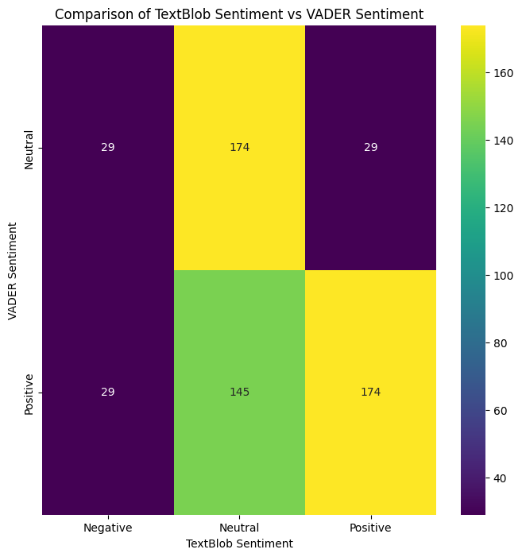

Percentage Rating vs Sentiment Relationship

Subtask:
Summarize the relationship between percentage ratings and sentiment. Re-generate and interpret the box plot titled 'Percentage Rating vs Sentiment'.
Reasoning: Now that the VADER sentiment analysis explanation is complete, I will re-generate the box plot to visualize the relationship between percentage ratings and TextBlob sentiment as requested by the subtask.
sns.boxplot(x="Sentiment", y="Percentage_Rating", data=df)
plt.title("Percentage Rating vs Sentiment")
plt.show()
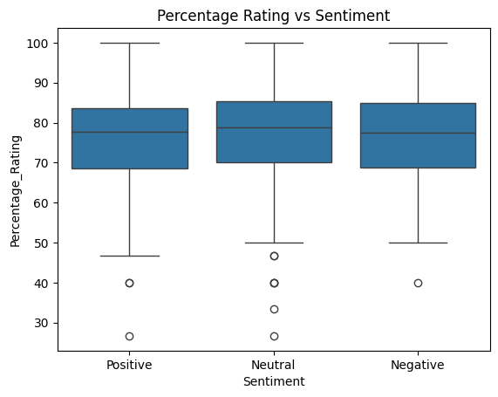

print(dept_rating)

Output:- Basic Course
MSC INFORMATION TECHNOLOGY 87.083000
BACHELOR OF COMMERCE (BANKING AND INSURANCE) 87.000000
BACHELOR OF ARTS 86.705750
BACHELOR OF MANAGEMENT STUDIES 81.842500
BACHELOR OF COMMERCE (ACCOUNTING AND FINANCE) 81.521500
MSC ANALYTICAL CHEMISTRY 80.678750
MSC ORGANIC CHEMISTRY 79.470500
BACHELOR OF SCIENCE 77.040833
MSC COMPUTER SCIENCE 76.910750
BACHELOR OF COMMERCE 74.384750
MA PSYCHOLOGY 72.014500
MSC MICROBIOLOGY 70.762000
MSC PHYSICS 68.500000
B.VOC FOOD TECHNOLOGY 68.000000
B.SC. COMPUTER SCIENCE 67.073500
MSC DATA SCIENCE 60.999500
Name: Percentage_Rating, dtype: float64

Interpretation of Average Percentage Rating by Basic Courses
The bar plot titled 'Average Percentage Rating by Basic Courses' (already generated in the notebook) and the dept_rating series provide insights into student satisfaction across different basic course categories. The series is sorted in descending order of average percentage rating.
Observations:
- Top-Performing Basic Courses: Courses like 'MSC INFORMATION TECHNOLOGY' (87.08%), 'BACHELOR OF COMMERCE (BANKING AND INSURANCE)' (87.00%), and 'BACHELOR OF ARTS' (86.71%) show the highest average percentage ratings, indicating strong student satisfaction in these foundational areas.
- Mid-Range Performance: A large group of basic courses, including 'BACHELOR OF MANAGEMENT STUDIES' (81.84%), 'BACHELOR OF COMMERCE (ACCOUNTING AND FINANCE)' (81.52%), 'MSC ANALYTICAL CHEMISTRY' (80.68%), and 'BACHELOR OF SCIENCE' (77.04%), fall into a solid mid-range of satisfaction.
- Lower-Rated Basic Courses: The lowest average percentage ratings are observed in 'MSC DATA SCIENCE' (61.00%), 'B.SC. COMPUTER SCIENCE' (67.07%), 'B.VOC FOOD TECHNOLOGY' (68.00%), and 'MSC PHYSICS' (68.50%). These categories appear to have comparatively lower student satisfaction.
Key Takeaways:
- Similar to the course-level analysis, there's a noticeable variation in average satisfaction across basic course categories. However, the range of ratings for basic courses (from ~61% to ~87%) is slightly narrower than for individual course names.
- Information Technology and certain Bachelor of Commerce and Arts programs are consistently rated highly, suggesting strong performance and student engagement in these broader fields.
- Science and vocational courses, particularly Data Science and some Computer Science and Physics programs, appear to be areas where student satisfaction is lower on average. This might warrant further investigation into curriculum, teaching methodologies, or career support within these specific disciplines.
- The overall trend suggests that while some basic course areas are performing excellently, others require focused attention to improve student experiences and satisfaction.

Average Percentage Rating by Basic Courses Analysis

Subtask:
Summarize the average percentage ratings by basic courses. Re-generate and interpret the bar plot showing 'Average Percentage Rating by Basic Courses'.
Reasoning: I need to re-generate the bar plot for 'Average Percentage Rating by Basic Courses' as instructed, using the dept_rating Series. This will allow for visual interpretation of the data.
plt.title("Average Percentage Rating by Basic Courses")
dept_rating.plot(kind="bar")
plt.title("Average Percentage Rating by Basic Courses")
plt.xlabel("Basic Course")
plt.ylabel("Percentage Rating")
plt.xticks(rotation=45, ha='right') # Rotate labels for better readability
plt.tight_layout() # Adjust layout to prevent labels from being cut off
plt.show()

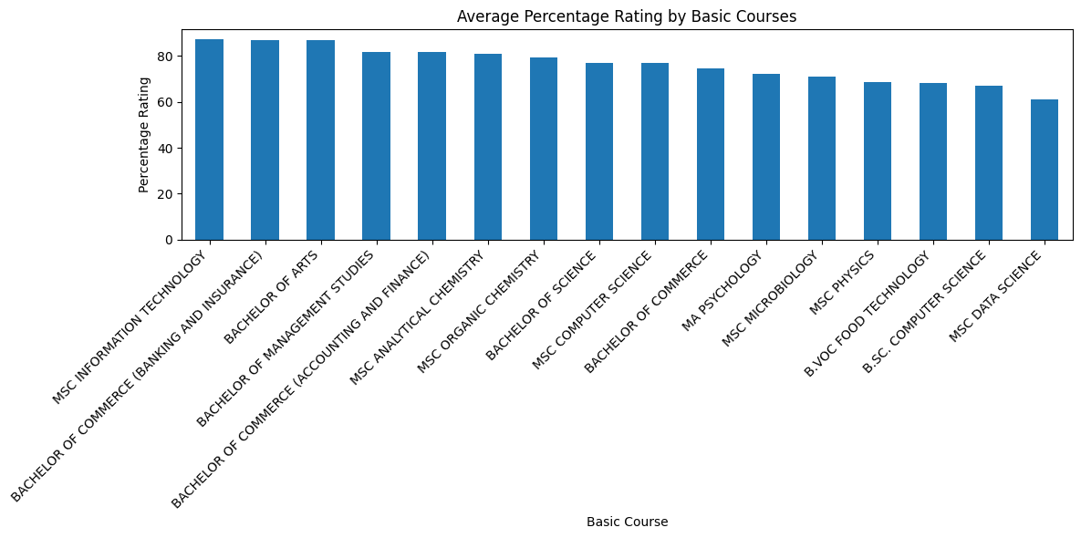

Common Words and Complaints

Subtask:
Summarize the common words in student feedback and common complaints. Re-generate the word clouds for 'Common Words in Student Feedback' and 'Common Complaints (Negative Feedback)'.
Reasoning: First, I will re-generate the word cloud for 'Common Words in Student Feedback' using the 'text' variable and display it, as instructed by the subtask.
text = " ".join(df["Clean_Feedback"])

wordcloud = WordCloud(
width=800,
height=400,
background_color="white"
).generate(text)

plt.figure(figsize=(10,5))
plt.imshow(wordcloud)
plt.axis("off")
plt.title("Common Words in Student Feedback")
plt.show()
Output:-
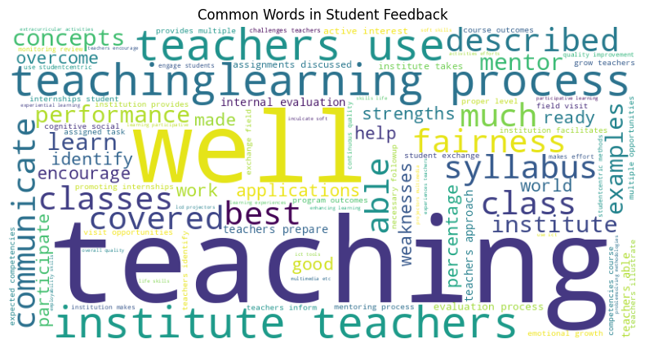
Reasoning: Now that the word cloud for common words in student feedback has been re-generated, I will re-generate the word cloud for 'Common Complaints (Negative Feedback)' using the negative_text variable and display it, as instructed by the subtask.
negative_text = " ".join(df[df["Sentiment"]=="Negative"]["Clean_Feedback"])

neg_wordcloud = WordCloud(
width=800,
height=400,
background_color="white"
).generate(negative_text)

plt.figure(figsize=(10,5))
plt.imshow(neg_wordcloud)
plt.axis("off")
plt.title("Common Complaints (Negative Feedback)")
plt.show()

Output:-
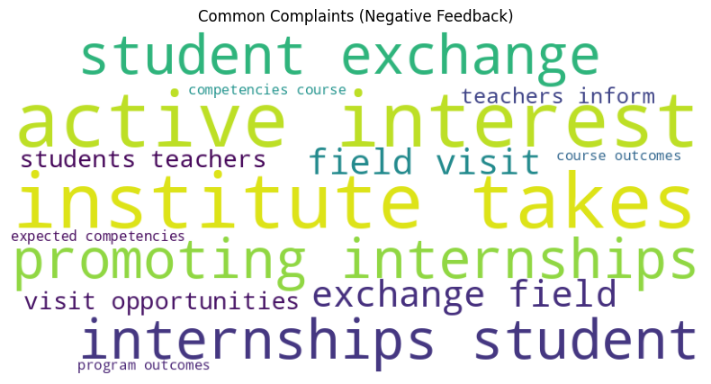

📝 Key Insights & Recommendations
Based on the comprehensive analysis of the student satisfaction survey data, the following key insights and recommendations have been identified:

Key Insights:
Top Rated Events (Strong Performance Areas):
- Fairness of internal evaluation process by teachers (84.30%): Students highly appreciate the impartiality in evaluation. This suggests that the assessment methods and their application are perceived as just and equitable.
- Teachers' communication skills (83.95%): Effective communication from teachers is a significant strength, indicating clear delivery of information and good interaction with students.
- Teachers' preparation for classes (81.79%): High ratings here suggest that educators are consistently well-prepared, contributing to an effective learning environment.
Areas for Improvement (Low Rated Events):
- Teachers identifying strengths and providing challenges (72.30%): This indicates a need for teachers to better recognize individual student strengths and tailor challenges to foster growth effectively.
- Use of ICT tools by teachers (71.68%): A lower percentage suggests an opportunity to enhance the integration of modern teaching technologies like LCD projectors and multimedia in classrooms to improve engagement and learning.
- Teaching and mentoring process facilitating cognitive, social, and emotional growth (71.58%): This is the lowest-rated aspect, highlighting a critical area where the institution can focus on improving holistic student development beyond just academic instruction.

Overall Trends from Analysis:
- High Overall Satisfaction: The Percentage Rating Distribution histogram shows a skewed distribution towards higher ratings, with a large number of ratings falling between 70% and 85%, indicating a generally positive sentiment. While Neutral sentiment is high (55%) in TextBlob analysis, Positive feedback (35%) also accounts for a significant portion, confirming overall satisfaction.
- Course and Basic Course Performance Variation: There's notable variability in satisfaction across different Course Names and Basic Courses. While IT and some Commerce/Arts programs show high satisfaction, some Data Science, Computer Science, and Physics courses receive lower average ratings, indicating specific programs requiring targeted intervention.
- Sentiment Discrepancies: The comparison between TextBlob and VADER sentiment analysis shows differences, particularly in negative classifications. This suggests that the nuances of student feedback might be complex and require a multi-faceted approach to sentiment interpretation.
- Weak Correlation between Percentage Rating and Sentiment: The Percentage Rating vs Sentiment box plot reveals that even negative feedback can sometimes be associated with relatively high percentage ratings, and vice-versa. This implies that numerical ratings alone don't always perfectly align with the explicit sentiment expressed in the feedback.
- Common Complaints: Word clouds highlighted areas related to internships, student exchange, and active interest from the institute in these aspects as common complaints, suggesting a need to enhance career-oriented support and experiential learning opportunities.

General Recommendations:
- Improve logistics and time management: Addressing operational aspects can enhance the overall student experience.
- Increase interactive sessions: More engagement in classes can improve student participation and learning outcomes.
- Enhance audio/visual arrangements: Upgrading and ensuring proper functioning of ICT tools will directly address one of the lower-rated areas.
- Collect structured feedback regularly: Continuous and well-structured feedback mechanisms can provide more actionable data for ongoing improvement.

Summary:

Data Analysis Key Findings
- Top-Rated Aspects of Student Experience: Students rated the "Fairness of internal evaluation process by teachers" highest at 84.30%, followed closely by "Teachers' communication skills" at 83.95%, and "Teachers' preparation for classes" at 81.79%.
- Key Areas for Improvement: The lowest-rated aspects were "Teachers identifying strengths and providing challenges" (72.30%), "Use of ICT tools by teachers" (71.68%), and "Teaching and mentoring process facilitating cognitive, social, and emotional growth" (71.58%).
- Overall Satisfaction: The analysis indicates a generally positive sentiment, with a large number of ratings falling between 70% and 85%. TextBlob analysis showed 35% positive feedback, alongside 55% neutral sentiment.
- Course-Specific Variation: There was notable variability in satisfaction across different course names and basic courses, suggesting that some programs like Data Science, Computer Science, and Physics require targeted intervention due to lower average ratings.
- Sentiment Analysis Nuances: A comparison between TextBlob and VADER sentiment analysis revealed discrepancies, particularly in negative classifications, indicating that interpreting student feedback sentiment can be complex.
- Correlation Between Rating and Sentiment: A weak correlation was observed between percentage ratings and expressed sentiment; sometimes, even negative feedback was associated with relatively high percentage ratings, and vice-versa.
- Common Complaints: Recurring themes in student complaints, as highlighted by word clouds, included internships, student exchange, and the active interest from the institute in these aspects.

